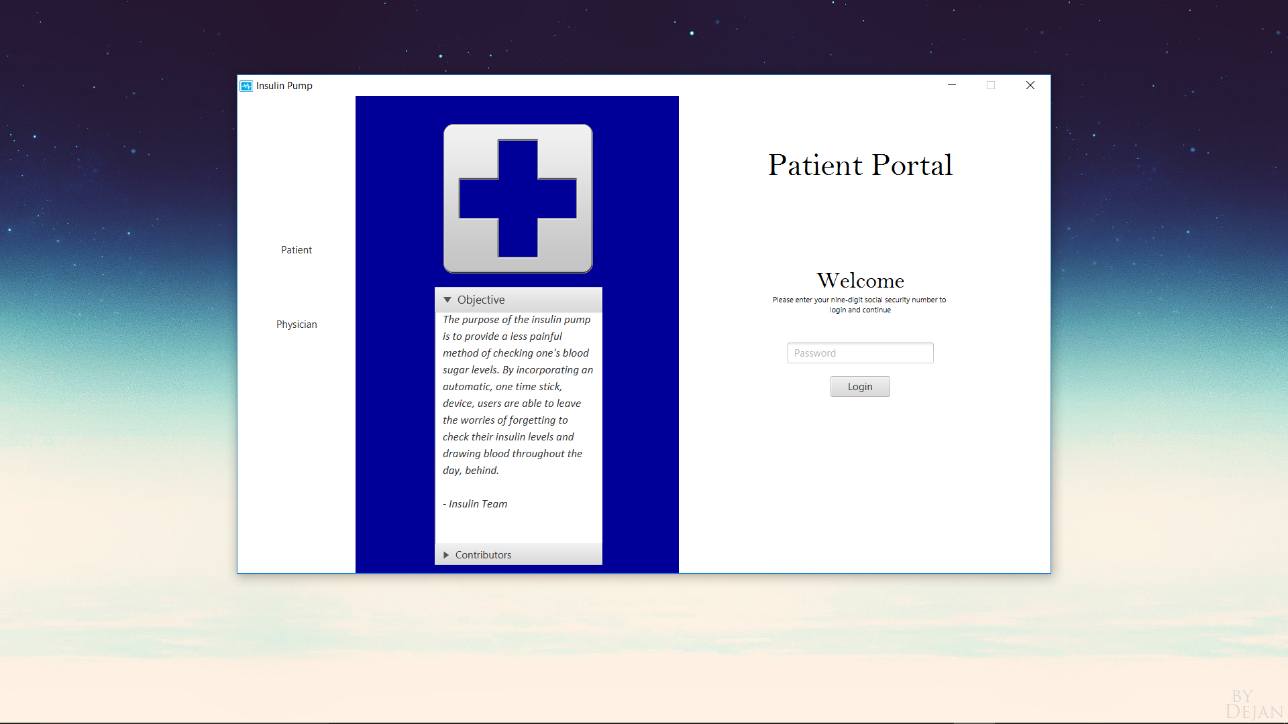

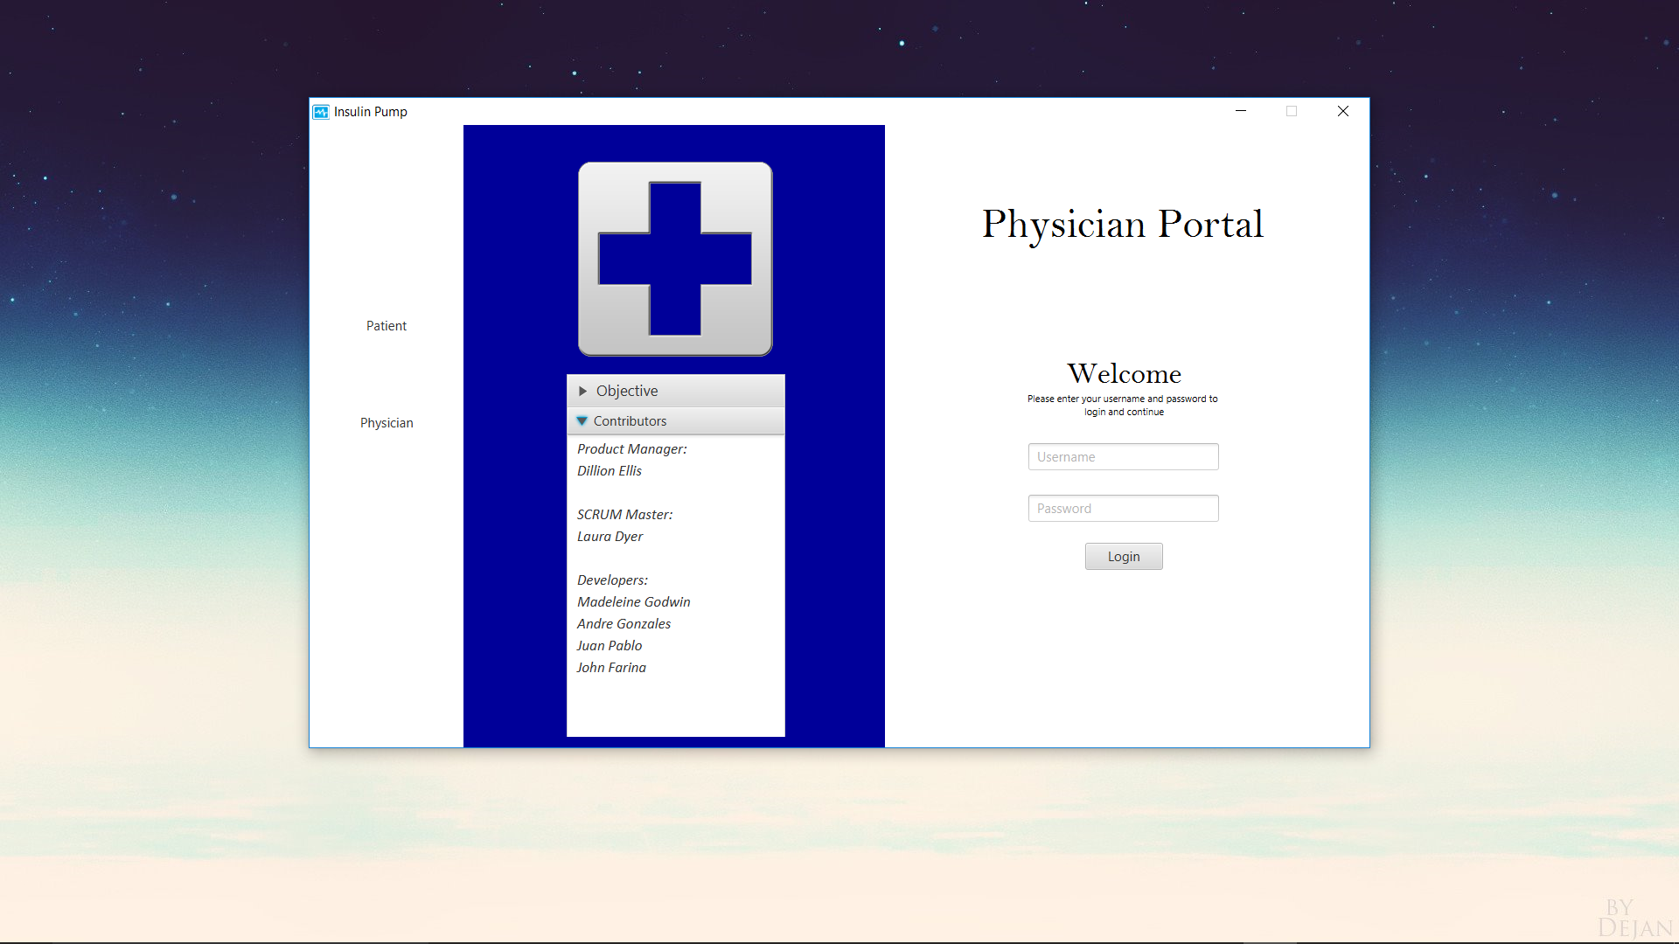

Icon code:

stage.getIcons().add(**new** Image("file:src/InsulinMain/blueHeartbeat.png"));

Icon is located in src folder